What is a First Responder?

A First Responder is an individual who is trained with knowledge and skills to respond to medical or trauma emergency 911 calls. This may be when a neighbour calls for an ambulance, or when an accident in the community occurs, a First Responder would attend to the scene first and help out the injured until Paramedics would arrive on scene.

Who can become a First Responder?

- Over 18 years of age
- Current Criminal Record Check (within 6 months of course date)
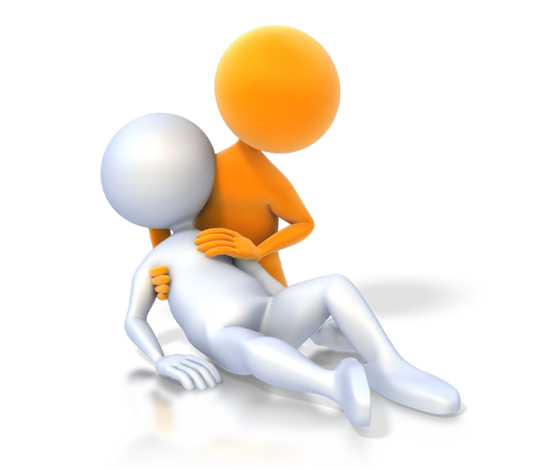
- Completed Application Form including Signed Confidentiality Pledge

How long is the course?
The course is a 40-hour certificate program whose partnership involves Saskatchewan Health and the Canadian Red Cross, which would be instructed at the Elbow Community Hall over 2 weekends:

March 17 (Virtual) 6:00pm - 9:00pm March 31 (Virtual) 6:00pm - 9:00pm
March 18 8:30am - 4:30pm April 1 8:30am - 4:30pm
March 19 8:30am - 4:30pm April 2 8:30am - 4:30pm

What do you need to do to maintain the certification?

All that is required is to maintain yearly educational requirements such as certain mandatory subjects and CPR C, all of the education is provided throughout the year.
How do I Register?

To register, or if you have any further questions, please call Mike Slater at
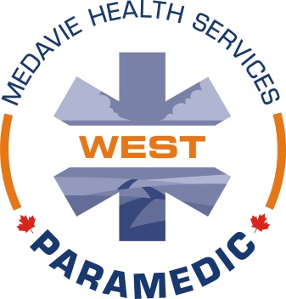
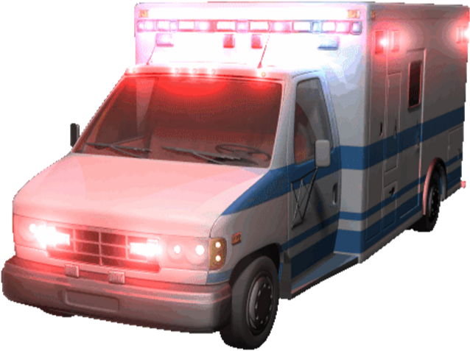
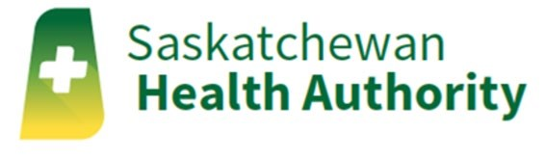
Moose Jaw (MHS West) @ 306-694-2151 or email Michael.Slater@medaviehs.com

