Elbow Friendship Club

invites you to a

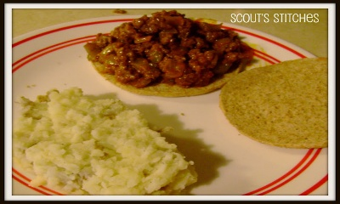

[This Photo](https://xstitchandcrafts.blogspot.com/2011/09/guest-posting-and-new-food-friday.html) by Unknown Author is licensed under [CC BY-SA-NC](https://creativecommons.org/licenses/by-nc-sa/3.0/)

Free Lunch

***sloppy joe, bun, cole slaw, dessert & beverage***

**Thursday, January 30**

**11:30 – 1:00**

**@ Harbor Golf Community Center**

**Everyone Welcome**